Date: 10.01.2025
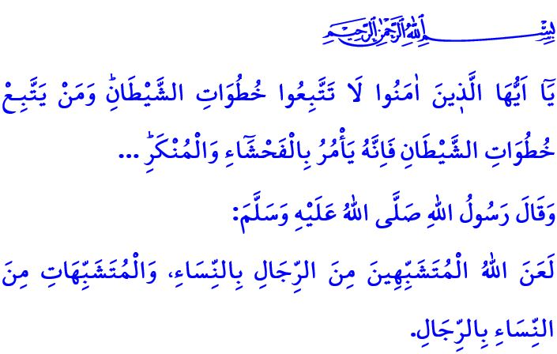TO PROTECT THE HUMAN NATURE IS TO PROTECT THE FAMILY
Dear Muslims!
Our Almighty Lord (swt) created man and woman from the same essence and granted each of them unique spiritual and physical qualities. These traits, referred to as human nature, are neither a cause for superiority nor a cause for deficiency between men and women. This is because being created as a man or a woman is not a matter of personal choice; it is the will of Allah the Almighty (swt), a reflection of His divine wisdom. Women as women and men as men are both important, valuable, and unique in their own right. Both sexes are complementary and supportive of one another, not competitors or substitutes. They are like two halves of an apple.
Dear Believers!
Today, one of the greatest threats facing humanity is the attempt to erase the natural essence of men and women. One such effort, known as desexualization, seeks to distort the spiritual and physical characteristics of human beings, aiming to transform women into men and men into women. It is an endeavor to disregard divine will and reduce humanity to an entity devoid of identity. It is an act of encouraging alcohol consumption, drugs, and illegitimate relationships, leading generations toward disaster by exploiting children, and darkening the future of humanity.
Dear Muslims!
In the Holy Qur’an, attention is drawn to this subject when the Satan says,وَلَاٰمُرَنَّهُمْ فَلَيُغَيِّرُنَّ خَلْقَ اللّٰهِۜ "I will order them to alter Allah’s creation.”, as the actions he uses to lead people astray from the right path are described. Yes, all activities carried out under the name of desexualization are immoral and perverse. It means exceeding the limits set by Allah (swt) and rebelling against His commands. As our Prophet (saw) says, “Allah has cursed men who try to be like women, and women who try to be like men.” Therefore, no misguided ideology that Allah (swt) has forbidden and that interferes with our natural creation can be justified under the guise of freedom. Deviant movements that undermine reason and conscience, leading to the rise of numerous societal issues, cannot be normalized under the pretext of human rights. Supporting such perversions that threaten the future of humanity through films, television shows, cartoons, social media posts, digital games, advertisements, music, art, and cultural events is a great sin and a heavy responsibility.
Esteemed Believers!
Desexualization is a major threat that not only targets the identity of individuals but also darkens the future of societies. The greatest strength we have against this threat is the family. The family is a home of mercy and compassion, established by a man and a woman who possess the spiritual and physical maturity deemed legitimate by our religion and appropriate by our laws, in the presence of witnesses through marriage. The family is the most valuable treasure we can have to nurture healthy generations. It is a school of knowledge, wisdom, and understanding for our children. It is a fortified fortress, a strong shelter that safeguards our generations from harmful tendencies and evils.
Dear Muslims!
It is a commandment of Islam to establish and protect the family, enriching and strengthening it through the blessing of children. It is our shared duty to take the necessary measures against harmful trends that threaten the family. Therefore, let us remain vigilant against those who seek to destroy the institution of the family and corrupt society. Let us make our family a center of compassion and affection. Let us dedicate time to our children and offer them our attention and love. Let us continue to raise them in accordance with their natural identities, remaining steadfast in our commitment to our national and spiritual values. Let us choose clothes and toys that are appropriate for the gender and age of our children. Let us carefully teach them the awareness of privacy that Islam enjoins. Let us not leave them at the mercy of toxic networks in virtual environments. Let us guide them so that they do not become victims of wrong friends. When they reach the age and maturity to marry, let us support them in establishing their own family homes. Let us avoid words, behaviors, and practices that make our young people fearful of marriage. Let us not complicate engagement, marriage, and wedding ceremonies. Let us not forget that all unions outside of marriage are considered fornication and are haram. It is a great sin that brings about the wrath of Allah (swt).
I would like to conclude this Friday’s khutbah with the meaning of the Verse 21 of the Surah al-Nur: “O believers! Do not follow the footsteps of Satan. Whoever follows Satan’s footsteps, then ˹let them know that˺ he surely bids ˹all to˺ immorality and wickedness...”

Nisa, 4/119.
Ibn Hanbal, V, 243.
Nur, 24/21. General Directorate of Religious Services

